**Project Design Phase-II**

**Data Flow Diagram & User Stories**

| Date | 03 October 2022 |
| --- | --- |
| Team ID | PNT2022TMID51657 |
| Project Name | Inventory management for retailers [ B8-2A4E] |
| Maximum Marks | 4 Marks |

**Data Flow Diagrams:**

A Data Flow Diagram (DFD) is a traditional visual representation of the information flows within a system. A neat and clear DFD can depict the right amount of the system requirement graphically. It shows how data enters and leaves the system, what changes the information, and where data is stored.

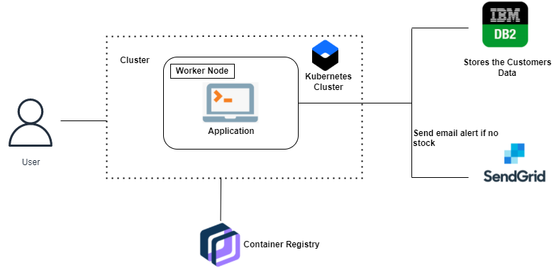 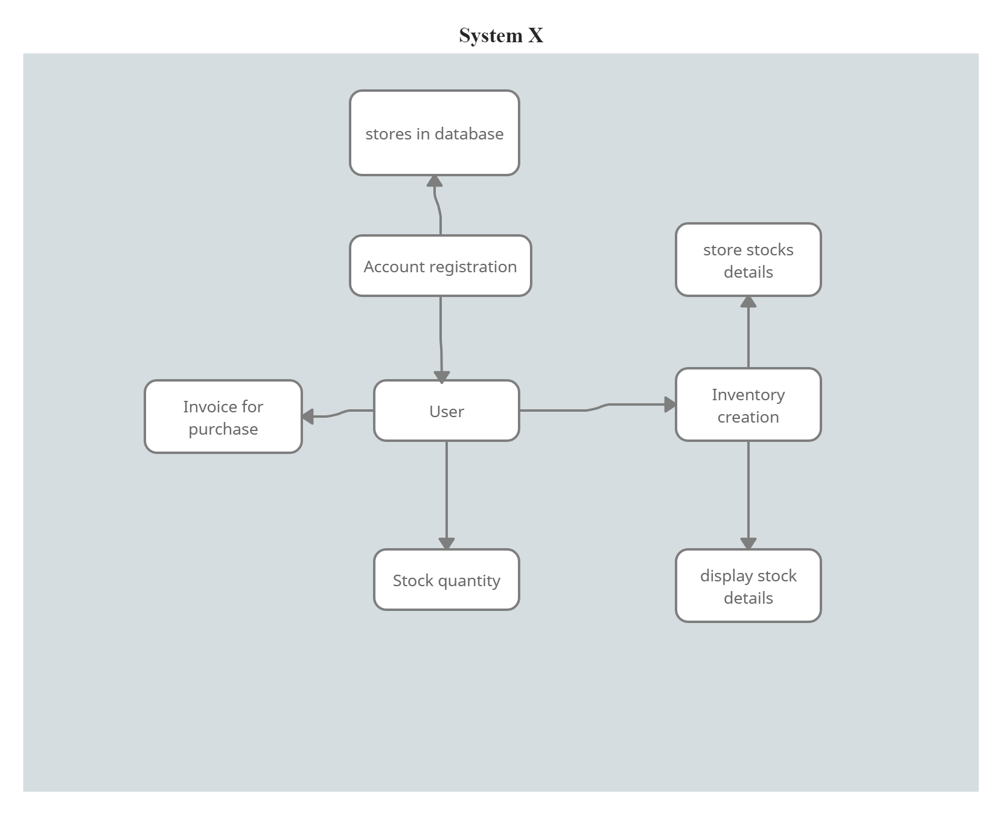

**User Stories**

Use the below template to list all the user stories for the product.

| **User Type** | **Functional Requirement (Epic)** | **User Story Number** | **User Story / Task** | **Acceptance criteria** | **Priority** | **Release** |
| --- | --- | --- | --- | --- | --- | --- |
| Customer (web user) | Registration | USN-1 | As a user, I can register for the application by entering my email, password, and confirming my password. | I can access my account / dashboard | High | Sprint-1 |
| Customer (web user) | Registration | USN-2 | As a user, I will receive confirmation email once I have registered for the application | I can receive confirmation email & click confirm | High | Sprint-1 |
| Customer (web user) | Registration | USN-3 | As a user, I can register for the application through mobile number. | I can register & access the dashboard . | Low | Sprint-2 |
| Customer (web user) | Registration | USN-4 | As a user, I can register for the application through Gmail | I can register & access the dashboard . | Medium | Sprint-1 |
| Customer (web user) | Login | USN-5 | As a user, I can log into the application by entering email & password | I can login & access the dashboard . | High | Sprint-1 |
| Customer (web user) | Dashboard | USN-6 | As a user ,I can access all my accounts details in dashboard. | I can see all my details in dashboard | low | Sprint-2 |
| Customer (Web user) | Storage | USN-7 | As a user,i can store all my details in storage. | I can store,update and delete details in database. | High | Sprint-1 |
| Customer Care Executive |  | USN-8 | As a user,I can deal my query with customer care executive | I can clear all my queries . | Low | Sprint-2 |
| Administrator | administration | USN-9 | As a administrator ,i can solve my customers requests. | I can solve all my customer’s requests. | Medium | Sprint-1 |